OSI model (Open systems Interconnection)

* Application layer
  + User Interface (using HTTP, SMTP, MQTT)
* Presentation layer
  + Raw user input to usable format (zb. Html)
  + encryption
  + compression
* Session layer
  + Opens/closes communication
  + Session = time between opening and closing
  + Set checkpoints every few MB to resume form there if connection got lost
  + Ensures session stays open as long as needed
* Transport layer
  + Segments data
  + flow control (avoid congestion)
  + error control (tcp asks for re sending
  + assigns ports
* Network layer
  + Segments get split into packets
  + Sends the data between diffrent networks
* Datalink layer
  + Packets get broken down to frames
  + Sends the data in internal network
* Physical layer
  + 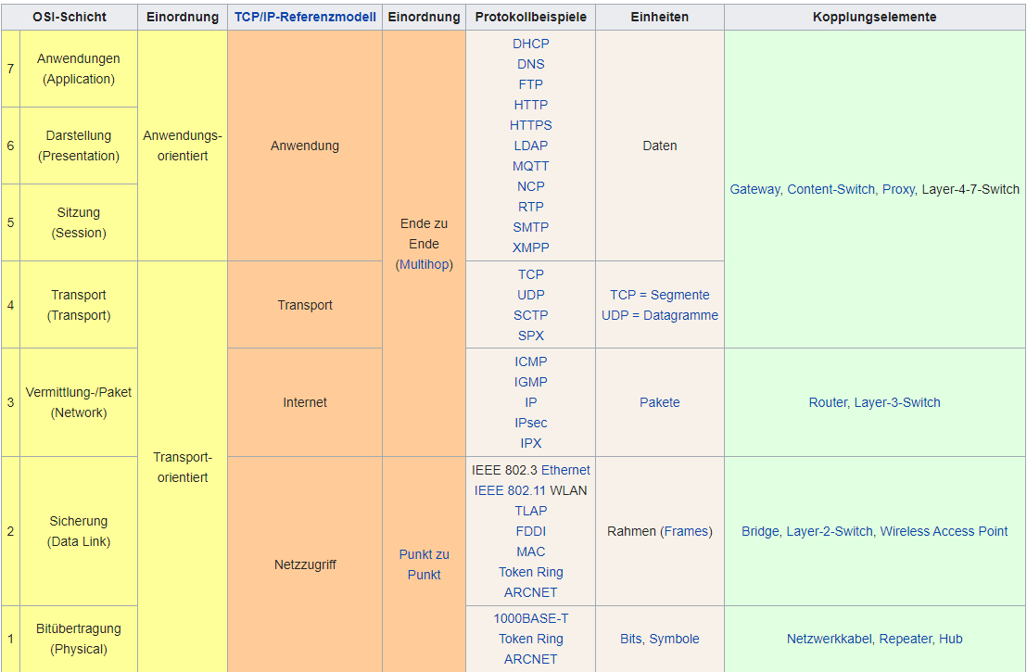Frams get converted into bits and send of